Heavy Weight # 10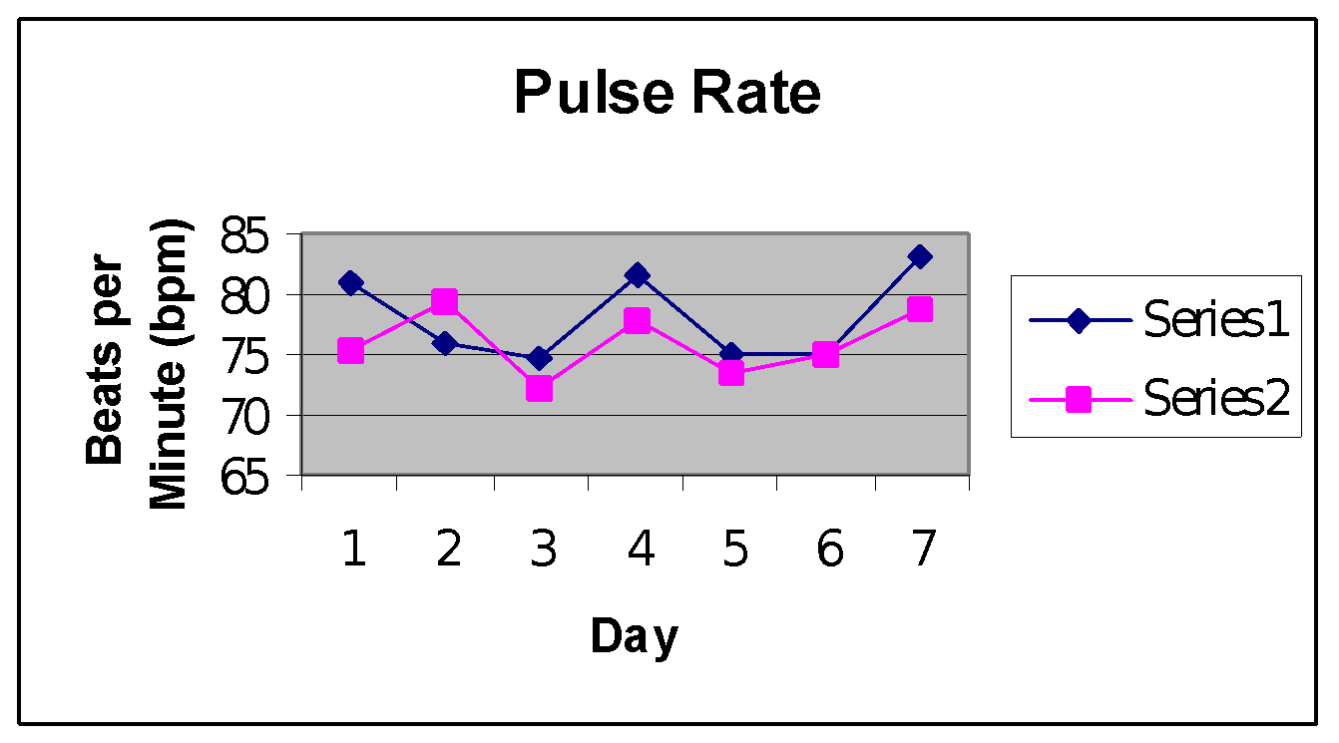

**Series #1 w/o strip; Series #2 w/ strip**

# Series #1 mean: 78.0515 bpm; Series #2 mean: 76.3531 bpm

The Series #2 mean has a .089 probability of occurring by chance when compared to the Series #1 mean. This shows strong evidence that the nasal strip decreased the subject’s pulse rate.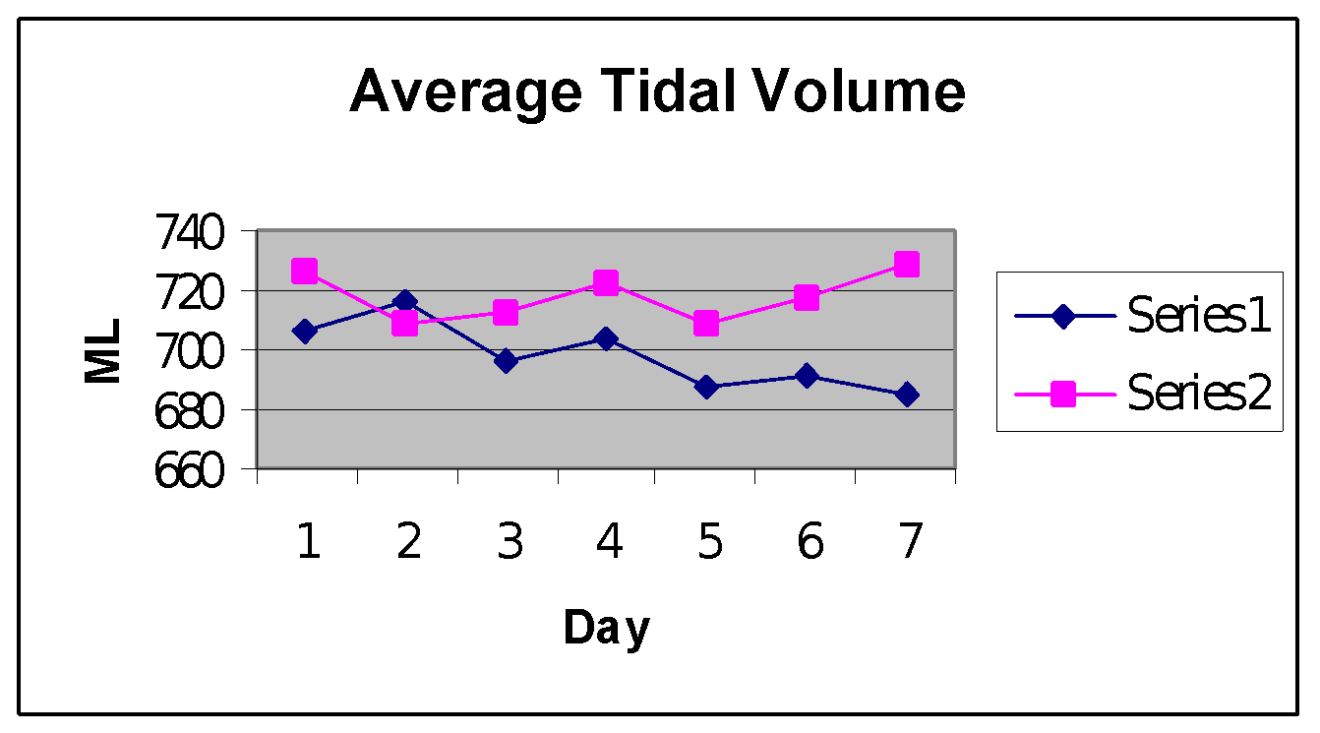

Series #1 mean: 700.79 ml; Series #2 mean: 717.7916ml

The Series #2 mean has a .0254 probability of occurring by chance when compared to the Series #1 mean. This gives strong evidence that the nasal strip increased the subject’s tidal volume.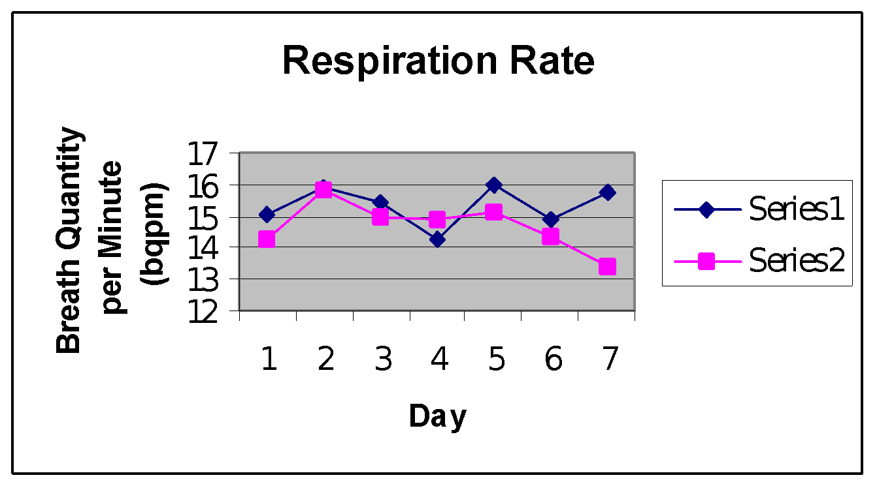

Series #1 mean: 15.26 bqpm; Series #2 mean 14.317 bqpm

The Series #2 mean has a .0158 probability of occurring by chance when compared to the Series #1 mean. This shows strong evidence that the nasal strip decreased the subject’s respiratory rate.

Series #1 mean: 320,889.233 ml ; Series #2 mean: 308,298.67 ml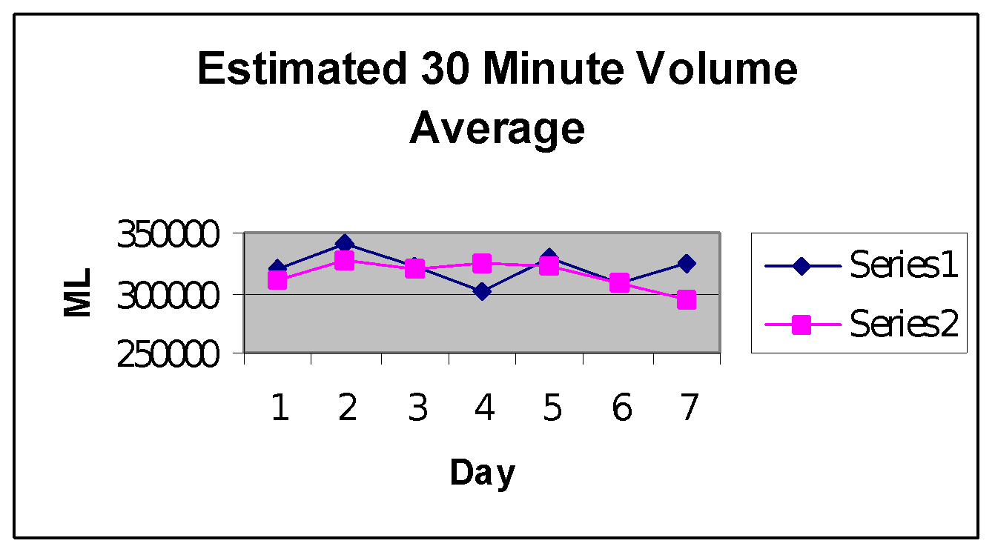

The Series #2 mean has a .3174 probability of occurring by chance when compared to the Series #1 mean. This shows weak evidence that the nasal strip either increased or decreased the subject’s 30 minute volume.

]